**INTRODUCTION**

In our project we create a resume& Curriculam Vitae using by Canva .First we Ensure that each team member has a Canva account and is logged in. Ensure that each team member has a Canva account and is logged in.

1. **Choose a Template:** Canva offers a wide range of resume templates. Have your team explore the available options and select a template that best fits your industry, style, and preferences.
2. **Customize the Template:** Begin customizing the chosen template as a team. Here's how to do it collaboratively:
   * **Edit Text:** Each team member can take responsibility for different sections (e.g., contact information, summary, work experience). Click on the text in the template and edit it to reflect individual information.
   * **Add Content:** Upload individual photos if you want to include profile pictures. Insert any specific icons, logos, or other graphics relevant to your team or industry.
   * **Design Elements:** Customize the color scheme, fonts, and layout to match your team's branding or preferences.
   * **Collaborate:** Canva allows for real-time collaboration. Use the "Share" feature to invite team members to edit the document simultaneously.
3. **Choose a Template:** Canva offers a wide range of resume templates. Have your team explore the available options and select a template that best fits your industry, style, and preferences.
4. **Customize the Template:** Begin customizing the chosen template as a team. Here's how to do it collaboratively

.

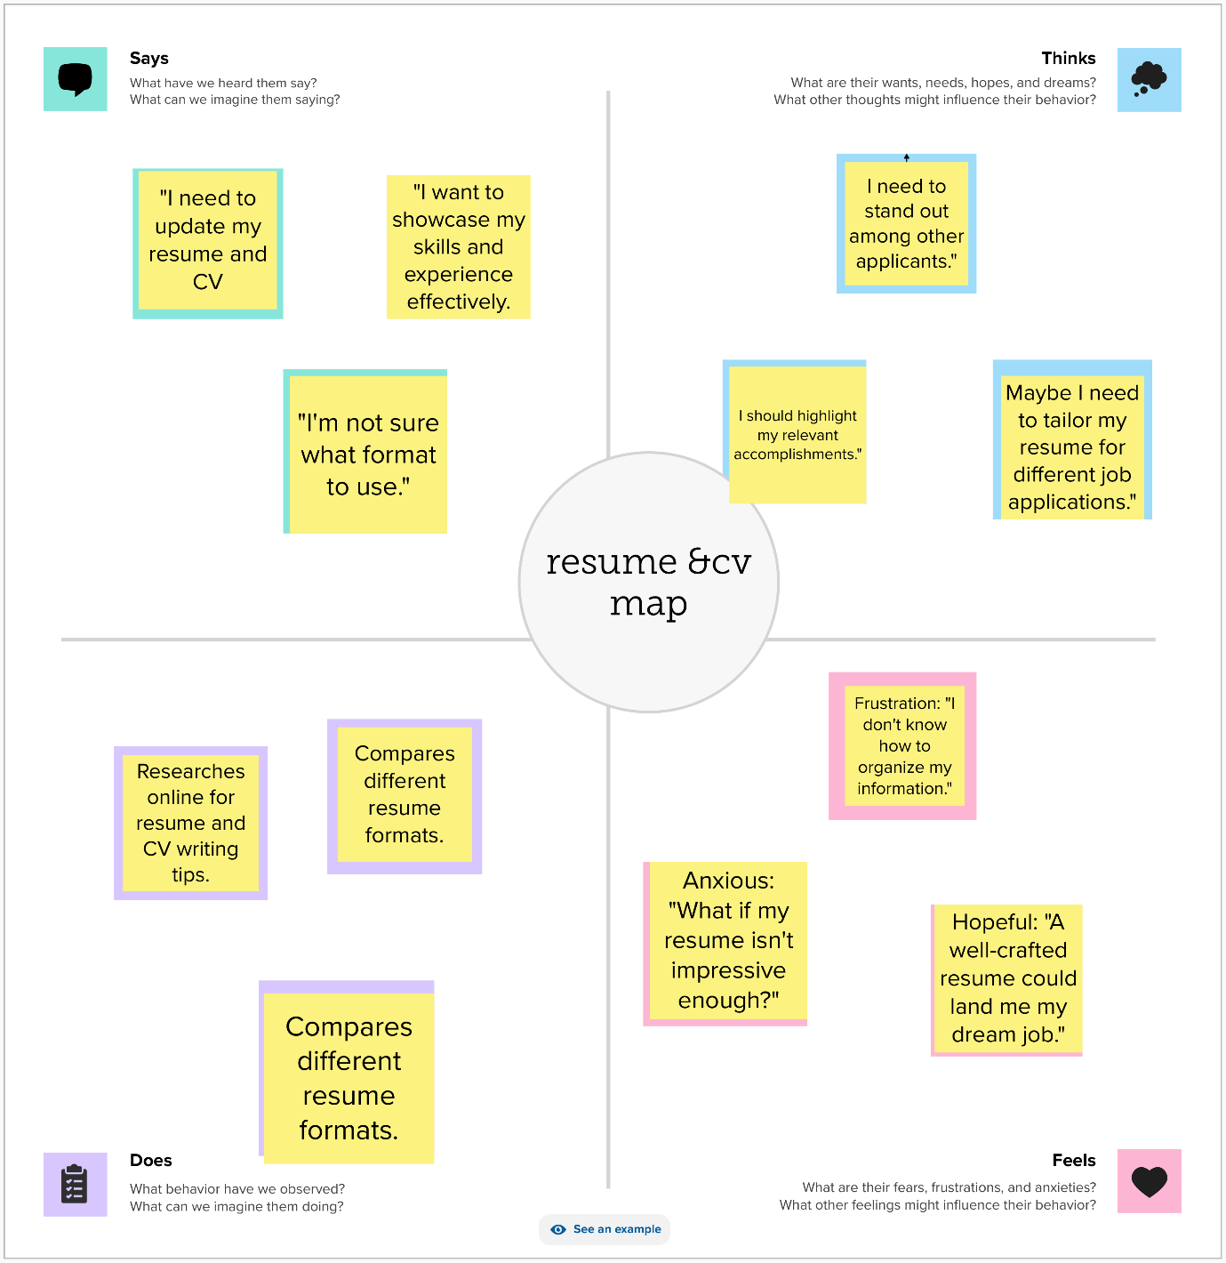

**EMPATHY MAP**

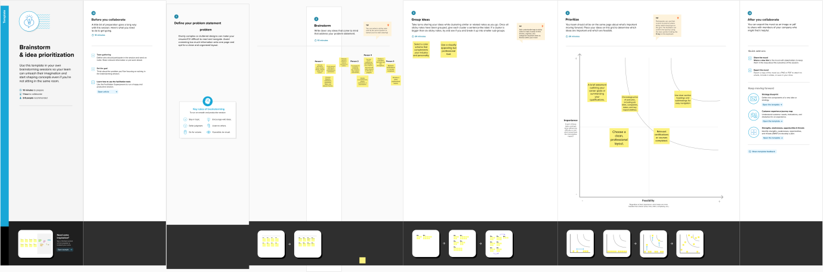

BRAINSTORING

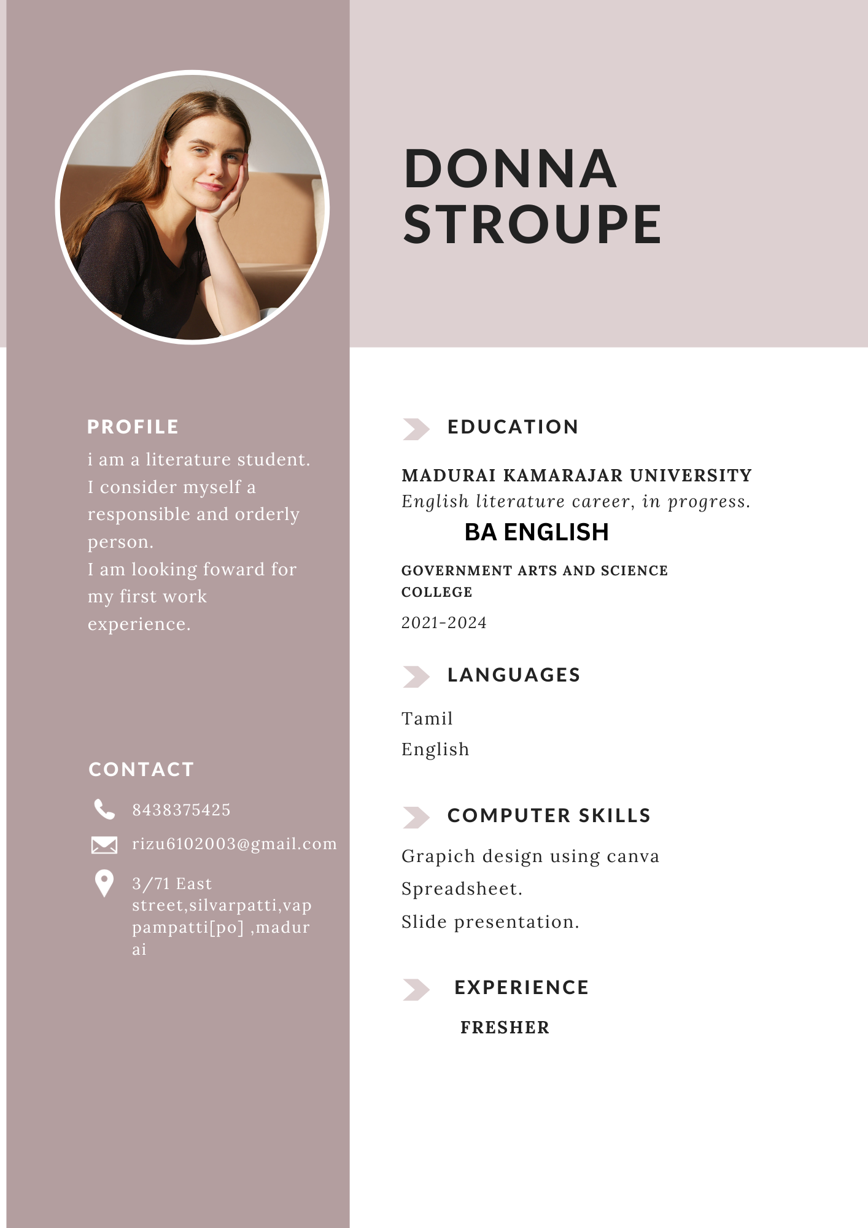

PROJECT RESULT

**Advantages of Creating a Resume:**

1. **Showcasing Qualifications:** A resume allows you to present your qualifications, skills, and experiences in a structured and concise manner, making it easy for employers to evaluate your suitability for a job.
2. **Professional Image:** A well-crafted resume conveys a professional image, demonstrating that you've put effort into presenting your qualifications. It's often the first impression an employer has of you.
3. **Customization:** You can tailor your resume for specific job applications, highlighting the most relevant skills and experiences for a particular position.

**Disadvantages of Creating a Resume:**

1. **Lack of Personalization:** Resumes can sometimes oversimplify a candidate's unique qualities and experiences, making it challenging to stand out in a competitive job market.
2. **Brevity:** The brevity required in a resume may lead to omitting valuable information about your qualifications and experiences.
3. **Overemphasis on Formal Education:** Resumes tend to prioritize formal education, which may not accurately reflect a candidate's true capabilities or potential.
4. **Risk of Misrepresentation:** Some candidates may exaggerate or misrepresent their qualifications and experiences on a resume, which can lead to ethical and legal issues.
5. **Subjectivity:** Resumes often rely on subjective evaluation by hiring managers, which can introduce biases in the hiring process.



**EXPLANATION VIDEO**

**THANK YOU**